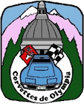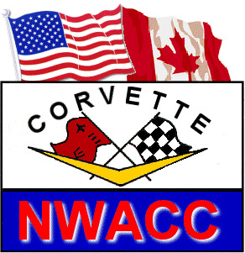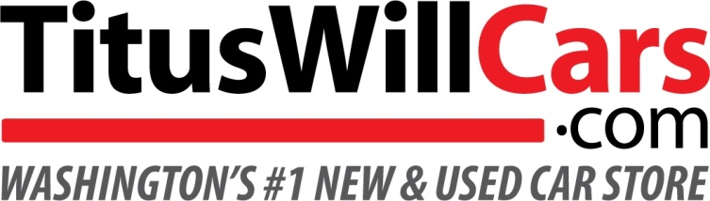
Corvettes de Olympia proudly presents:
Capital City Vette Fest XVIII
Please join us for the last NWACC show of the year!

When: Sunday, August 27, 2023
What: NWACC Show n’ Shine & People’s Choice Corvette Show
Where: Titus Will Chevrolet; 2255 Carriage Loop, Olympia, WA, 98502

Registration opens at 7:30 a.m. Registration closes at 9:30 a.m. Rags down at 10:00 a.m.
Awards by 3:00 p.m.
NWACC Judged Shine & Show
Classes: C-1 (53-62) C-2 (63-67) C-3 (68-82) C-4 (84-96) C-5 (98-04) C-6 Coupe (05-13)
C-6 Convertible (05-Cur13) C-7 Coupe (14-19) C-7 Convertible (14-19) C-8 Coupe (20-present)
C-8 Convertible (20-present) Under 10K miles (any year) People’s Choice (chosen by public vote) Dealer’s Choice and other special awards

Owner’s Name(s) _____________________________________________________________________
Street Address________________________________________________________________________
City__________________________________ State/Province________________ Zip_______________
Phone_______________________ Email___________________________________________________
Corvette Club Affiliation________________________________________ NWACC Member? Yes No
1st Corvette Year_________ Coupe / Convertible Color __________ Class ________ Mileage ___________
2nd Corvette Year_________ Coupe / Convertible Color __________ Class ________ Mileage ___________
Pre-registration is encouraged to save money!
NWACC Judged Show n’ Shine (includes People’s Choice) ___ @ $30 =$_____ ($35 after 8/1, $40 day of show)
People’s Choice only (Non Judged) ___ @ $20 =$_____ ($25 after 8/1, $30 day of show)
Event T-Shirt (pre-paid only) S, M, L, XL (add $5 for 2X & 3X) ____ @ $20 ($25 for 2X & 3X) =$_______
Pre-registration must be postmarked by August 1, 2023. Total Amount Enclosed $_____________
Make Checks Payable to: Corvettes de Olympia, P.O. Box 2154, Olympia WA 98507
Thanks to our supporters: